parms <- list(r = 1, K = 10,
a1 = 0.38, a2 = 0.51, psi1 = 1, psi2 = 1, e1 = 0.5, e2 = 0.5,
b1 = 0.2, b2 = 0.42, m1 = 0.05, m2 = 0.05, e1H = 0.5, e2H = 0.5,
o1 = 0.8, o2 = 0.8, h1 = 1, h2 = 1, c1 = 0.9, c2 = 0.9, d = 0.02, DL = 0)
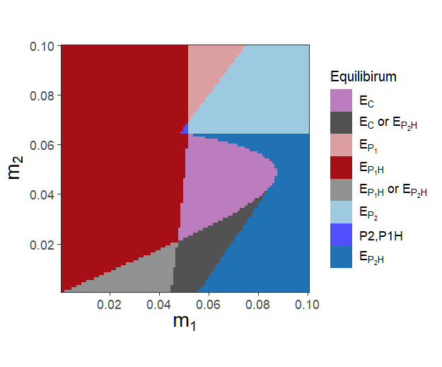
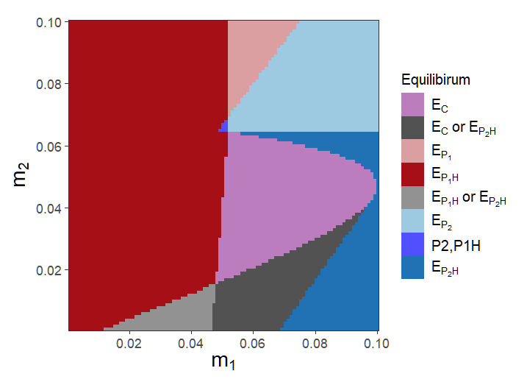(psi = 0.8)
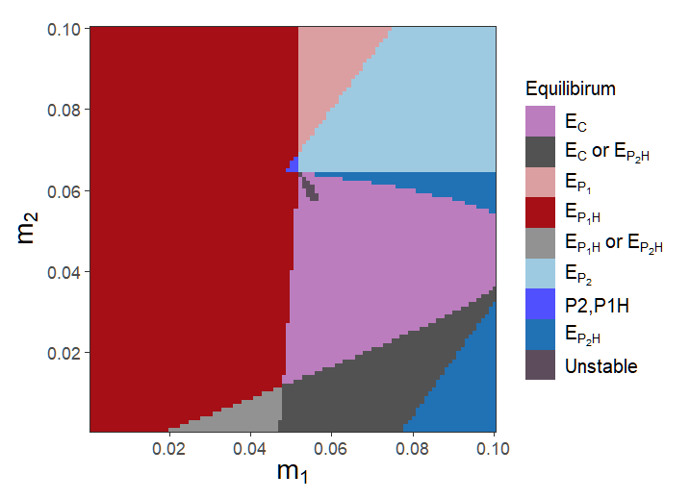(psi = 0.7)
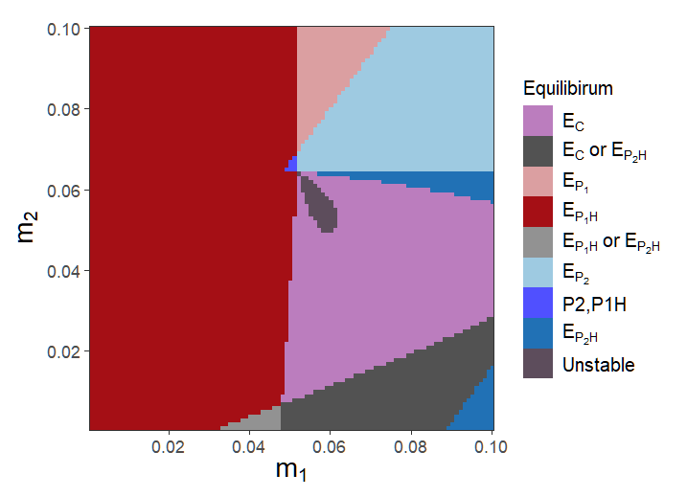(psi = 0.8)

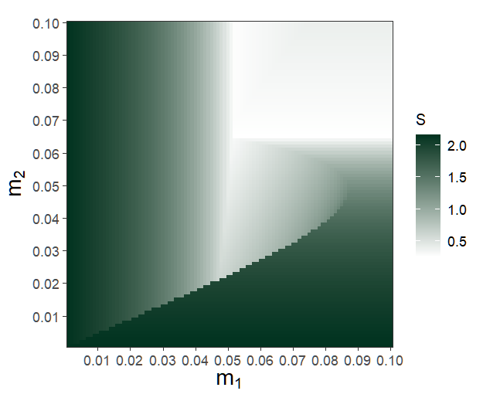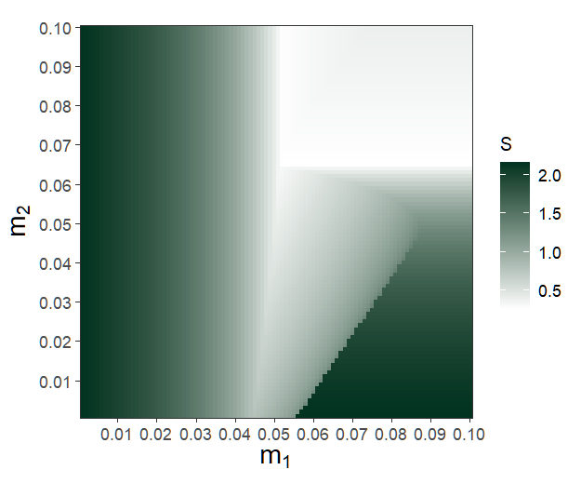
Alternative stable state - > covered with $E_{P_{2}H}$ (left)
Covered with $E_{P_{1}H}$ and $E_{C}$ (right)

